
Proposal and Quotation for WhatsApp Chatbot Unoffical API
https://www.veloxn.com/
Introduction -

The table below details the costs associated with this project.
Name | Unit Price | Years | Subtotal
Proposal and Quotation for WhatsApp Chatbot Unoffical API | ₹40,000 | 1 | ₹40,000
Discount 75% |  |  | -₹30,000
SUB TOTAL |  |  | ₹10,000
Special Discount Allowed | -₹5000 |  | -₹5000
TOTAL |  |  | ₹5000
TOTAL Including GST 18 % |  |  | ₹5,900
Payment required is ₹5,900
Note* - Offer Valid for 1 Days only

Bank Details:

VELOXN PRIVATE LIMITED
AC Number – 259958439076
IFSC Code – INDB0000702
Bank Name – Indusind Bank
UPI ID - veloxnservices@okicici
QR Code – 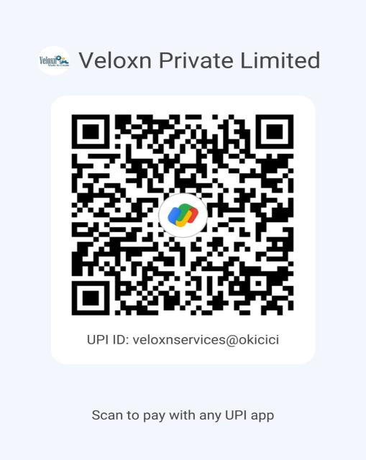

COMPANY:
Veloxn Private Limited
Iconic Tower C, Corenthum, Sector-62, Noida, UP - 201301, India www.veloxn.com
sales@veloxn.com
91-7292001010
GST - 06AAICV7138B1ZE

